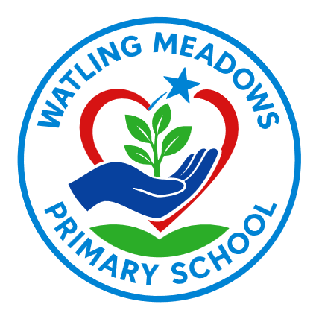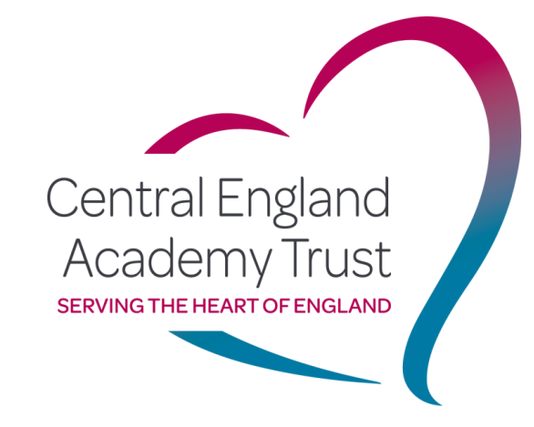
School Uniform Policy

Policy Number:
Approval date:
Review date:

Adopted by the Board of Trustees/Governing Body
Signed Chair of Governors
Signed Chair of Trustees
Signed CEO

The review of this policy will be as and when required in response to national requirements and in light of continuous school based monitoring and evaluation data.

Uniform Policy for children from Reception to Year 6
We are very proud of our school uniform at Watling Meadows Primary School and believe that it is important that all children are wearing the correct uniform every day. This is because uniform promotes:
❖ A sense of belonging to the school community
❖ Pride in being a pupil at Watling Meadows
❖ Smart appearance - a clear focus on learning and not on fashion
❖ Safeguarding – it keeps us safe as we know who belongs to our school
❖ Equality of opportunity for children – it is not about what fashionable clothes they can afford
School uniform is regarded as suitable wear for school and good value for money by the most parents and carers. It is also designed with health and safety in mind.
Where to purchase school uniform:
School uniform can now be ordered online from Match Fit Kit Schoolwear. Or from their store on Weddington Road Nuneaton.
All uniform items can also be purchased in the school colours from local supermarkets and shops without the school logo.
Our school uniform is as follows:
✓ Plain black or grey tailored trousers (no leggings or jeans)
✓ Plain black or grey skirt – knee high
✓ Plain black or grey tailored shorts
✓ Blue and white checked summer dress
✓ Plain sky-blue or white polo shirt
✓ Navy-blue school jumper
✓ Sensible plain black shoes (no boots, logos, white soles, sandals or jelly shoes etc.)
✓ Plain grey, black, white or red socks or tights (not bright colours or patterns)
✓ Plain headbands (no JoJo bows, flowers etc.)
Our school PE Kit is as follows:
✓ Plain black shorts, leggings or skort
✓ Plain sky-blue or white t-shirt
✓ Black pumps or plain black trainers
✓ Navy blue school jumper or navy-blue hoody
✓ Plain dark coloured tracksuit bottoms can be worn for PE during cold weather
✓ Swimsuits/trunks and towels for swimming lessons

Please make sure that all items of uniform are clearly marked / labelled with your child’s name.
Jewellery
We do not allow children to wear jewellery in school on health and safety grounds. The exceptions to this rule are stud earrings in pierced ears, watches and small objects of religious significance.
We ask the children to remove these objects during PE and games to prevent them from causing injury to either themselves or others. If, for any reason, a religious bangle cannot be removed then it must be covered by a wrist sweatband. This must be provided from home.
Hairstyles
The school does not permit children to have inappropriate hairstyles or haircuts that serve as a distraction to the child or to other children. This includes dyed or coloured hair, tram lines and patterns. Long hair should be tied back at all times.
Modifications to the School Uniform
Watling Meadows Primary School welcomes children from all backgrounds and faith communities. If there are serious reasons, for example on special educational needs or religious grounds, why parents / carers want their child to wear clothes that differ from the school uniform, the school will look sympathetically at such requests.
If any parent would like to modify the school uniform, they should make representation, in the first instance, to the Headteacher. If Parents / Carers are unable to comply with the School Uniform Policy for any reason, then a note should be sent to the class teacher explaining why this is the case and when it is anticipated that the child will be back in full school uniform.
Support for parents and carers
We would not discriminate against a child or family having financial difficulties in providing school uniform. Please speak with our staff for advice and support in this matter.

